Paul Collado
CSC-208-60
Sept 30, 2010

ColladoCh03Page141

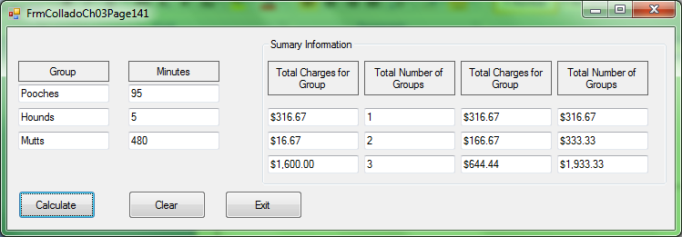

Public Class FrmColladoCh03Page141

Private Sub BtnCalculate_Click(ByVal sender As System.Object, ByVal e As System.EventArgs) Handles BtnCalculate.Click

Const RatePerMin As Decimal = 200D
Dim min1 As Integer = Val(Me.Txtgrpmin1.Text)
Dim min2 As Integer = Val(Me.Txtgrpmin2.Text)
Dim min3 As Integer = Val(Me.Txtgrpmin3.Text)

Dim group1charge As Decimal = (RatePerMin / 60) * min1
Dim group2charge As Decimal = (RatePerMin / 60) * min2
Dim group3charge As Decimal = (RatePerMin / 60) * min3

Me.TxtTotalgrp1.Text = FormatCurrency(group1charge)
Me.TxtTotalgrp2.Text = FormatCurrency(group2charge)
Me.TxtTotalgrp3.Text = FormatCurrency(group3charge)

Dim TotalCharges As Decimal

Dim TotalGroups As Integer
Dim average1 As Decimal
Dim average2 As Decimal
Dim average3 As Decimal

Try
Me.Txtgrpmin1.Text = CDec(Me.Txtgrpmin1.Text)
Catch ex As Exception
MessageBox.Show("Please try again, enter an number and click calculate again", "ERROR")
Me.Txtgrpmin1.Clear()
End Try

Try
Me.Txtgrpmin2.Text = CDec(Me.Txtgrpmin2.Text)
Catch ex As Exception
MessageBox.Show("Please try again, enter an number and click calculate again", "ERROR")
Me.Txtgrpmin2.Clear()
End Try

Try
Me.Txtgrpmin3.Text = CDec(Me.Txtgrpmin3.Text)
Catch ex As Exception
MessageBox.Show("Please try again, enter an number and click calculate again", "ERROR")
Me.Txtgrpmin3.Clear()
End Try

If group1charge > 0 Then
TotalGroups = TotalGroups + 1
Me.TxtTotalnum1.Text = TotalGroups
TotalCharges = group1charge
average1 = TotalCharges / Val(Me.TxtTotalnum1.Text)
Me.TxtTotalAverage1.Text = FormatCurrency(average1)
Me.TxtTotalCharges1.Text = FormatCurrency(TotalCharges)
End If
If group2charge > 0 Then
TotalGroups = TotalGroups + 1
Me.TxtTotalnum2.Text = TotalGroups
TotalCharges = group1charge + group2charge
average2 = TotalCharges / Val(Me.TxtTotalnum2.Text)
Me.TxtTotalAverage2.Text = FormatCurrency(average2)
Me.TxtTotalCharges2.Text = FormatCurrency(TotalCharges)
End If
If group3charge > 0 Then
TotalGroups = TotalGroups + 1
Me.TxtTotalnum3.Text = TotalGroups
TotalCharges = group1charge + group2charge + group3charge
average3 = TotalCharges / Val(Me.TxtTotalnum3.Text)
Me.TxtTotalAverage3.Text = FormatCurrency(average3)
Me.TxtTotalCharges3.Text = FormatCurrency(TotalCharges)
End If
End Sub

Private Sub BtnClear_Click(ByVal sender As System.Object, ByVal e As System.EventArgs) Handles BtnClear.Click
Me.TxtGrpName1.Clear()
Me.TxtGrpName2.Clear()
Me.TxtGrpName3.Clear()
Me.Txtgrpmin1.Clear()
Me.Txtgrpmin2.Clear()
Me.Txtgrpmin3.Clear()

End Sub

Private Sub BtnExit_Click(ByVal sender As System.Object, ByVal e As System.EventArgs) Handles BtnExit.Click
Me.Close()
End Sub
End Class

